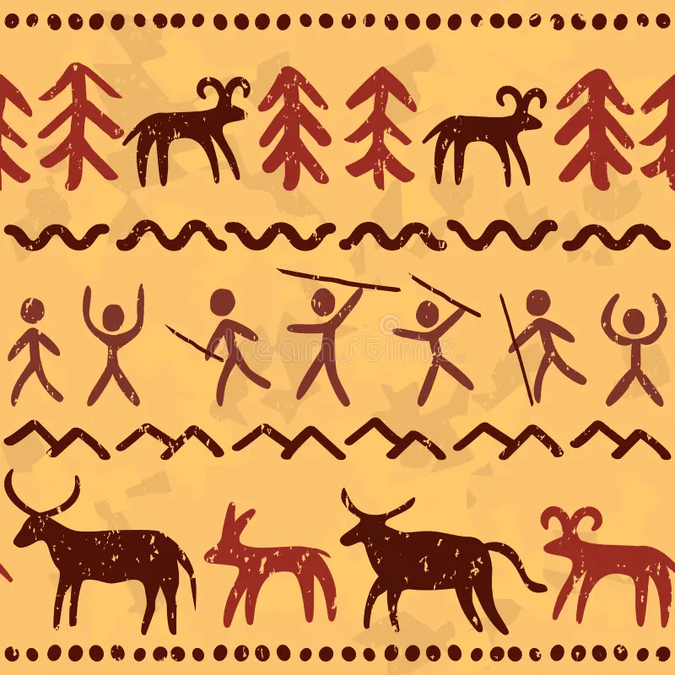

In English, we will be using ‘Stone Age Boy’, ‘The First Drawing’ and ‘How to Wash a Woolly Mammoth’ to inspire our writing, where we will write our own character descriptions, adventure narratives, instructions and diary entries. During this term, we will also be writing our own poems using characters from the texts.

In Maths this term, we will be revisiting our understanding of number and place value, as well as building our mental methods for addition, subtraction, multiplication and division. During this term, we will learn the properties of shapes, especially 3D shapes and learn strategies for problem solving.

In RE, we are going to be focusing on Christianity and Judaism, answering the two key questions: ‘What do Christians learn from the creation story?’ and ‘How do festivals and family life show what matters to Jewish people?’.

In Science, we will be learning about animals, including humans, where we will discover the importance of nutrition and how to be healthy, as well as finding out about the skeletal structure. Alongside these units, we will be revisiting enquiry skills and working scientifically to carry out a range of investigations.

Our Design & Technology this term will focus on designing and producing a nutritious vegetable stew, suitable for a Stone Age family. We will be learning a range of cooking techniques, as well as understanding how to prepare ingredients hygienically.

We will be learning how to stay safe online, in Computing this term: keeping passwords safe, following online rules and understanding what inappropriate behaviour on the internet looks like. We will then be learning how to use spreadsheets by collecting data, as well as coding to understand flowcharts.

Stone Age Boy

Year 3

Autumn Term

Our PSHE this term focuses on ‘being me in my world’, where we will be discussing our responsibilities and rights, why rules are needed and how our actions can affect others. We will also be ‘celebrating difference.’

Sketching and painting will be our focuses in Art this term, with the opportunity to apply our new skills to create our own cave artwork and silhouette painting of Stonehenge, linking to our theme.

In Geography, we will build our understanding of maps by learning the 8 points of a compass to help us compare prehistoric sites across Europe. We will also be using geographical vocabulary to describe the Lascaux Caves as well as Stonehenge and what happened there.

During our PE sessions, we will be developing our hockey and netball skills, including passing and receiving the ball with accuracy, to be able to play in a game situation. We will also be learning techniques to create our own gymnastic routines.

In History, we will be researching and gathering effective information about the Stone Age. We will record the key events in order of how things may have happened and learn what life may have been like for early settlers.

Key French culture and greetings will be our focus in the Autumn Term, where we will be learning all about France as a country and what other countries speak French. We will also be learning how to say the days of the week in French, as well as reading numbers 1-31!

In Music, we will be learning how to write down music to eventually help us compose our own music in a band!

**Homework**

Our weekly homework includes reading and times tables. Our expectation is that the children:

* Practice their times tables **once a week** on Times Table Rock Stars
* Read their reading book **3x a week** and record this on Boomhub

Children need to practise their times tables from the diamond band they are currently working on. Times Tables Rock Stars and reading planners will be checked every Thursday, and the new week for homework starts every Friday. Alongside this, **theme homework** will be set for the children to complete, where they will need to submit **10 creative pieces of their choice** throughout the term, to share with their peers and staff at CWJS. Feedback will then be provided to the children, which could be verbal or written.

**PE**

PE days are **Monday and Wednesday** for Juniper and Cherry Class. Although we try and stick to the same 2 days for PE, it is inevitable that for some weeks this will change due to unforeseen circumstances. For this reason, we ask that each child has their PE kit in school at all times. A PE kit should include a Cam Woodfield Junior t-shirt, black or blue shorts and daps or trainers. It is recommended that children have warm clothes for outdoor PE. This can include a jumper and jogging bottoms. Alongside this, children need a water bottle. Finally, if all children’s clothing can be named it makes it easier to return if lost.

**Times tables**

All children have log in details to access Times Tables Rock Stars, which can be used on any smart device via an app as well as on a computer. As a school, we focus on multiplication and corresponding division facts with regular practise of times tables through 21 facts every morning. It is the expectation of the National Curriculum that children learn their times tables with rapid recall up to 12 x 12. This means your child will need to learn each times table off by heart- without having to ‘work it out’.The children are tested every Friday using our times table scheme to reach 40 out of 40 to progress to the next diamond band. Every child has a tracking card to keep track of their times table progress.

**Reading**

All children will be provided with a school reading book and a log-in for our reading record app, Boomhub. It is essential that reading books are brought in to school each day and parents or carers update the app each time their child reads at home.  Guidance on using the Boomhub app will be provided with log in details. The book that your child receives is matched to their reading abilities for both word reading and comprehension. At the start of Year 3, the children’s phonetic knowledge will be assessed to identify any gaps and determine the book band colour they will start on.

Dates to remember:

Dates to remember:

Homework will be handed out every Friday and children will have until the following Wednesday to submit any work. This may change if a homework project lasting more than 1 week is set, however this will be communicated to the children and parents

Alongside homework, children will have weekly spellings and times tables. They are also expected to read regularly and should be recorded in their reading record. These are considered part of the homework for the week.