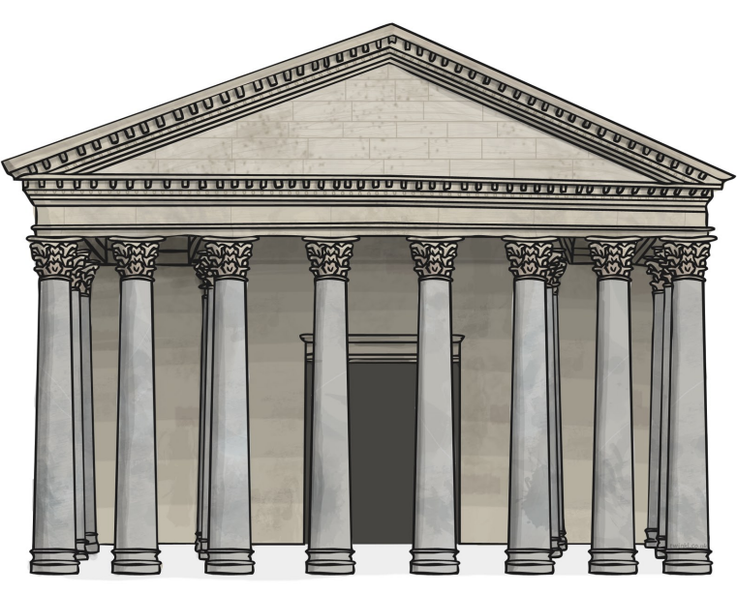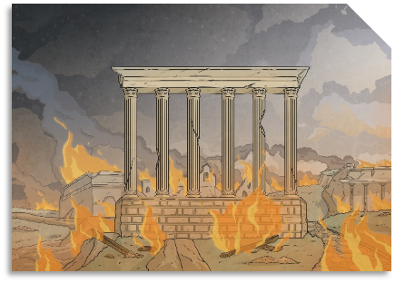

**The Romans**

**Year 3**

**Summer Term Homework**

History

Using some researched facts, create your own Ancient Rome quiz and test your friends and family.

Create your own Roman timeline in a creative way.

Create a poster about what life was like in Ancient Rome.

DT

Design or make your own mini-Roman shield.

Sketch and annotate your own design for a brand-new Roman Chariot for a charioteer.

Make a pair of Roman sandals out of paper or card that fit your feet!

Design your own Roman banquet using a range of balanced foods.

Geography

Make a tourist leaflet or information page about Hadrian’s Wall or another Roman site.

Compare what it is like to live in Italy vs the UK.

Find out about how volcanoes are formed or where they are found.

French

Learn how to say or spell different colours in French.

Record different types of weather in French. You might want to match these to months of the year they are most likely to be seen in.

Learn and record some Roman themed words in French.

Art

Sculpt a mini volcano out of playdough, clay or other mouldable materials.

Make a Roman mosaic out of small, coloured pieces of paper.

Create a Roman wreath headband to fit your head!

Make a pop-up Roman landmark or object in a card.

Computing

Using ‘Purple Mash’, explore a range of the available activities under the unit ‘The Romans’ or any other activities related to Ancient Rome. You might want to take a photograph of what you produce or hand this in on Purple Mash for your teacher to see.

PE

Practice some Roman sports such as running, javelin or weightlifting (supervised).

Demonstrate some different yoga poses you have learnt in school or through watching Cosmic Kids Yoga on YouTube. You might want to draw and label the poses you did or stick photographs in your book.

Science

Create a poster about the different parts of a plant and their functions.

Grow your own plant and measure its weekly growth.

Create a poster about what plants need to grow and why.   
Create a poster about the three different types of rocks.

|  |  |  |  |  |
| --- | --- | --- | --- | --- |
| For homework this term, you need to select 10 pieces that you would like to do to help you discover more about our theme and record each one using the table below. You need to select at least one activity from each subject box. Each piece of work that you produce must be of high quality, as they will be shared with your class. Be as creative as you can and have fun completing each activity, you might even like to do an activity as a whole family. Your class teacher will regularly check-in with you to find out how you are getting on with each project. Once you have completed a piece of work, remember to bring it into school or take a photo, so that your class teacher and class can see the fantastic work that you have produced. All 10 pieces must be completed and handed in by **Thursday 11th July 2024**. **Please note, you do not have to stick to the activities suggested.** If you have a better idea that links well to our theme and the subjects above, please feel free to do so. Additionally, if your child needs any support or resources, please ask their class teacher. | | | | |
| 1. | 2. | 3. | 4. | 5. |
| 6. | 7. | 8. | 9. | 10. |