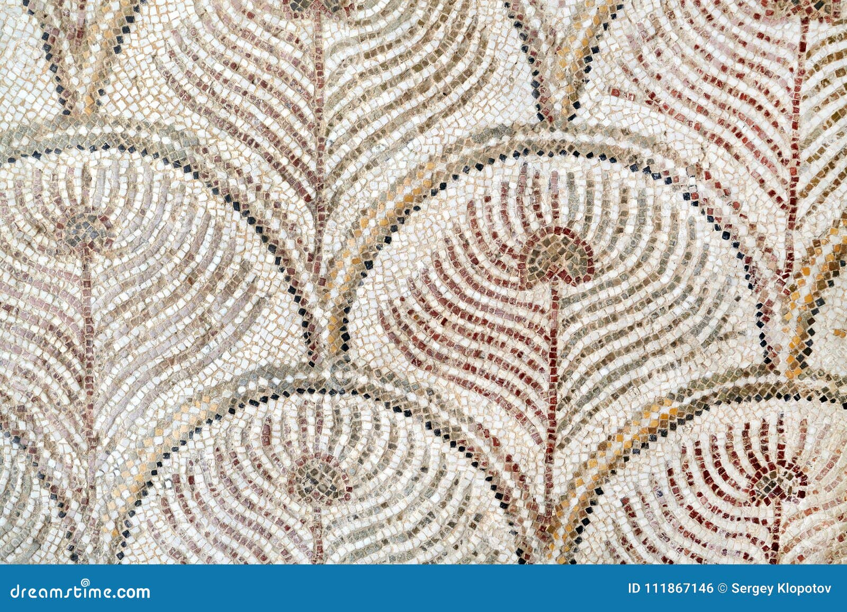

In English, we will be using the books ‘The Romans’ by Marcia Williams and ‘Escape from Pompeii’ by Christiana Balit to inspire our writing, where we will be writing our own non-chronological reports, limericks, historical narratives and explanation texts. We will also unpick these texts in our reading lessons, where we will complete tasks using our VIPERS skills.

In Maths this term, we will be learning about money and fractions. We will apply our sticky knowledge of money to buy items from the Roman trader market as part of our ‘theme maths’, which will feature in our corridor display. We also be learning to read the time on digital and analogue clocks. Later in the term, our focus will be measurement, geometry, and statistics.

In Science, we will be learning about plants in Term 5 and rocks in Term 6. During our ‘plants’ unit, we will be focusing on the different parts of a flowering plant and what they require to grow. By the end of this unit, we will design the perfect area for a plant to grow near the Colosseum. During our ‘rocks’ unit, we will look at types of rocks and soils whilst linking our new learning to some well-known scientists.

In RE this summer term, we will be focusing on Christianity. We will be answering the questions ‘What kind of a world does Jesus want?’ and ‘How can we make the world a better place?’.

During our DT lessons in Term 6, our focus will be construction, with the outcome of designing and creating our own mini-Roman chariots using wood! We will begin by disassembling toy cars to investigate different vehicle structures and discuss how these have changed over the years. We will use this to help us design our chariots.

The Romans

Year 3

Summer Term

In Computing, Year 3 will be looking at simulations and graphing, where they will explore the effects of simulations and create graphs to represent data. In addition, the children will be creating their own presentation on PowerPoint or Google Docs to share with the class.

Our PSHE this summer covers the units ‘Relationships’ and ‘Changing Me’, where we will be looking at friendship and helping others, as well as how human and animals bodies change over time.

Mosaics will be our focus in Art this term, with the opportunity to apply new skills to create our own Roman tiles, inspired by tiled floors and ceilings as seen in Ancient Rome. We will demonstrate some cross-curricular learning by designing our Roman tiles on laptops using Purple Mash, to experiment with different colours and patterns.

In Geography, we will be answering the enquiry questions:

* What was architecture, agriculture and trade like in Ancient Rome?
* What are volcanoes and earthquakes and how do they affect our lives?

During PE this term, we will be covering a variety of exciting sports! These include dance, yoga, athletics and cricket. The children will be taught a range of skills such as power poses, how to bat and bowl a cricket ball and run a relay. In our athletics lessons, we will be focusing on our speed, stamina and teamwork in preparation for sports day!

In History, we will be researching the Roman Empire. We will also be looking at the similarities and differences with the Romans and the Celts in Britain. By the end of the Roman unit, we will be able to explore artefacts left behind by the Romans to discover what each of them tell us about Roman life.

In French lessons, we will be learning how to pronounce and recognise different colours, as well as learning the different weather types and matching these to months of the year to link with our prior learning.

In Music in Term 5 and 6 we will be using the scheme ‘Charanga’ to learn the skills over time to perform our own piece of music for the units ‘Let Your Spirit Fly’ and ‘Glockenspiel Stage 1’.



PE

Children need their PE kit in school at all times. Although we try and stick to the same 2 days for PE it is inevitable that for some weeks this will change due to unforeseen circumstances. For this reason, we ask that each child has their PE kit in school at all times. PE days: Monday and Wednesday.

A PE kit should include a Cam Woodfield Junior t-shirt, black or blue shorts and daps or trainers. It is recommended that children have warmer clothes for outdoor PE. This can include a jumper and jogging bottoms. Likewise, as we head towards warmer weather it is advised that all children have a cap or hat in school. Alongside this, children need a water bottle. Finally, if all children’s clothing can be named it makes it easier to return if lost.

**Homework**

Our weekly homework includes reading and times tables. Our expectation is that the children:

* Practice their times tables **once a week** on Times Table Rock Stars
* Read their reading book **3x a week** and record this on Boomhub

Children need to practise their times tables from the diamond band they are currently working on. Times Tables Rock Stars and Boomhub will be checked every Thursday, and the new week for homework starts every Friday. Alongside this, **theme homework** will be set for the children to complete, where they will need to submit **10 creative pieces of their choice** throughout the term, to share with their peers and staff at CWJS. Feedback will then be provided to the children, which could be verbal or written.

**Times tables**

All children have log in details to access Times Tables Rock Stars, which can be used on any smart device via an app as well as on a computer. As a school, we focus on multiplication and corresponding division facts with regular practise of times tables through 21 facts every morning. It is the expectation of the National Curriculum that children learn their times tables with rapid recall up to 12 x 12. This means your child will need to learn each times table off by heart- without having to ‘work it out’.The children are tested every Friday using our times table scheme to reach 40 out of 40 to progress to the next diamond band. Every child has a tracking card to keep track of their times table progress.

**Reading**

All children will be provided with a school reading book and a log-in for our reading record app, Boomhub. It is essential that reading books are brought in to school each day and parents or carers update the app each time their child reads at home.  Guidance on using the Boomhub app will be provided with log in details. The book that your child receives is matched to their reading abilities for both word reading and comprehension. Some children in Year 3 have recently been re-assessed on their phonetic knowledge, so their book band colour may change during the summer term.

Dates to remember:

Dates to remember:

Homework will be handed out every Friday and children will have until the following Wednesday to submit any work. This may change if a homework project lasting more than 1 week is set, however this will be communicated to the children and parents

Alongside homework, children will have weekly spellings and times tables. They are also expected to read regularly and should be recorded in their reading record. These are considered part of the homework for the week.