How can I help at home?
Top strategies for Supporting Children with Anxiety Symptoms of anxiety
Anxiety tends to affect your child’s body, thoughts and feelings. They may also change the way they behave, including turning to certain coping behaviours to try to avoid completely or manage their anxiety.
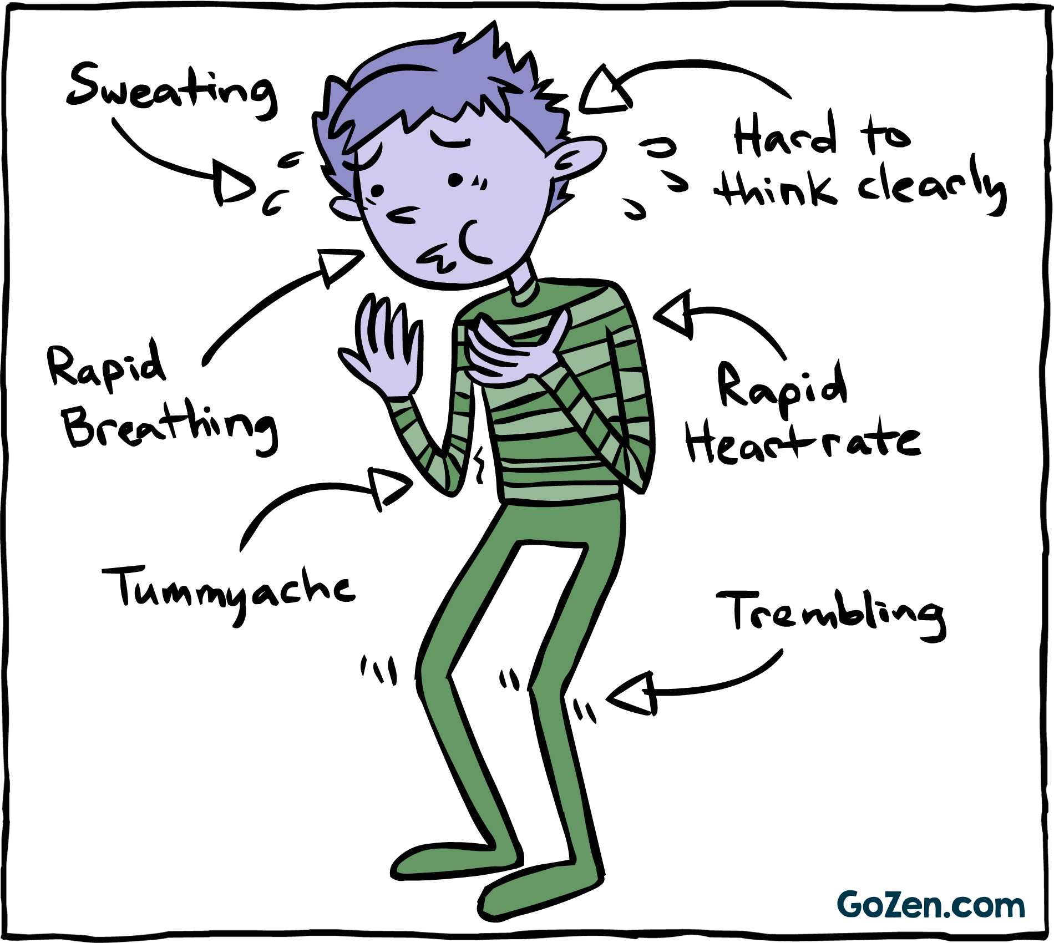
 | Physical Symptoms |  | Thoughts and Feelings
 | panic attacks, which can include having a racing heart, breathing very quickly, sweating or shaking  Shallow or quick breathing, feeling unable to breathe -feeling sick dry mouth sweating more than usual tense muscles wobbly legs  Irritable Bowel Syndrome (IBS), diarrhoea or needing to pee more than usual getting very hot |  | preoccupied by upsetting, scary or negative thoughts  nervous, on edge, panicky or frightened overwhelmed or out of control  full of dread or an impending sense of doom  alert to noises, smells or sights  worrying about being unable to cope with daily things like school, friendships and being in groups or social situations  worrying so much that it is difficult to concentrate and/or sleep
Coping Behaviours
- withdrawing or isolating themselves – including not wanting to go to school, be in social or group situations, be away from parents or try new things
- repeating certain behaviours, actions or rituals (often called ‘obsessive compulsive behaviours’)
- eating more or less than usual
- self-harming

Helping your child when they are feeling anxious:
When your child is in the middle of a very anxious moment, they may feel frightened, agitated or worried about having a panic attack. The important thing to do in the moment is to help them calm down and feel safe.
Strategies that might help:
- Breathe slowly and deeply together. You can count slowly to five as you breathe in, and then five as you breathe out. If this is too much, try starting with shorter counts. If it works for them, gradually encourage your child to breathe out for one or two counts longer than they breathe in, as this can help them and their body relax.
- Sit with them and offer calm physical reassurance. Feeling you nearby, or holding your hand or having a cuddle if it’s possible, can help your child to release or calm their anxiety.
- Reassure them that the anxiety will pass and that they will be okay. It can be helpful to describe it as a wave that they can ride or surf until it peaks, breaks and gets smaller.
- Ask them to think of a safe and relaxing place or person in their mind. If you haven’t tried this before, agree with them when they’re feeling calm what this place or person is. It could be their bedroom, a grandparent’s house, a favourite place in nature or somewhere they’ve been on holiday. Sometimes holding a memento of a relaxing place, like a seashell or pebble, can help.
- Try using all five senses together. Connecting with what they can see, touch, hear, smell and taste can bring them closer to the present moment and reduce the intensity of their anxiety. You might think together about five things they can see, four things they can touch, three things they can hear, two things they can smell and one thing they can taste.
- Encourage them to do something that helps them to feel calmer. This could be running, walking, listening to music, painting, drawing or colouring-in, writing in a journal, watching a favourite film or reading a favourite book.
Not all of these will work for all children. Over time you will be able to work with your child to find out what works best for them.

How to help your child manage their anxiety
Outside of moments when your child is feeling particularly anxious or panicky, there are things you can do over time to help them manage their anxiety and feel better.
Many of the strategies are to do with helping your child understand his/her own thoughts and feelings and helping them to discover what works for them in relation to feeling calmer. The more they understand this then the more confident they will feel with managing their own anxious feelings.
In calmer moments, talk with your child about their anxiety | Ask them what it feels like in their mind and body, and what things make them feel that way. It can be tempting to dismiss their worries because you want to reassure them, but it’s important to empathise with their experience and validate their feelings. You can find our tips on starting a conversation with your child here.
Think together about whether there’s anything in particular that’s making them feel anxious | This could include a friendship, a relationship with a family member, their schoolwork or a combination of things. Are there changes that could be made at home or school that would make things easier? If your child is worrying about things that are outside of their control, it might help to name together who is responsible for managing the problem – for example, you might say, “worrying about money is the parents’ job”.
Help your child to recognise the signs that tell them they’re getting anxious, so they know when to ask for help or help themselves. | Anxiety might make them feel sick or make their heart race. Getting to know these signs can make them less frightening and overwhelming when they happen.
Think together about the activities that help them to express themselves and reduce their anxiety. | Your child could try doing exercise, drawing or painting, writing in a journal, watching a favourite film, talking to friends or cooking and baking. These kinds of activities can help them to feel calmer.
Try activities that help us to relax, such as mindfulness, yoga or meditation. | Teenagers might like to use a mindfulness or meditation app such as Headspace or Calm. Remember that some people find these activities more helpful than others, so encourage your child to decide what works for them.

Make a worry box or self-soothe box | It might help your child to write down their worries and put them in a worry box, giving them a physical place where their worries can be ‘held’. Or they might prefer a self-soothe box, which they can fill with things that help them when they feel anxious – like photos, fidget toys, scented oils and positive quotes. You can find out how to make a worry box here, or a self-soothe box here - or watch the video below.
Help them do the things we know are important for our mental health: physical exercise, sleeping well, eating healthily, drinking water and spending quality time with loved ones. | Regular exercise is particularly important for anxiety because it can help to reduce the symptoms in the body. It doesn’t have to be strenuous – walking or gentle yoga can help.
Encourage them to cut out stimulants. | Reducing or stopping drinking coffee, caffeinated drinks and alcohol can help because these can all trigger the physical symptoms of anxiety.
Spend quality time together and talk about other things. | Even if it’s just for a little while, you can help your child take their mind off their worries by having fun, relaxing and laughing. Activities like playing a sport, sewing or playing musical instruments are great for focusing the mind on the moment. You can find more activity ideas here.
Seek professional help if you’re worried about your child’s mental health and things aren’t getting better. | Some children and young people with anxiety will need professional and specialist help to feel better. They may benefit from a specific diagnosis or a treatment such as medication or talking therapy. You can find more information about this below.

